J1939 protocol
Table of Contents
Introduction 1
J1939 Frame format 1
Address caim protocol(ACL) 2
Address Claiming Procedure 2
Request for Address Claim 3
Address Capability 3
Arbitrary address capable CA 3
Single address capable CA 3
Transport protocol 4
Diagnostic protocol 5
Reference 5

Introduction

J1939 Frame format
1 | 2 | 3 | 4 | 5 | 6 | 7 | 8 | 9 | 10 | 11 | 12 | 13 | 14 | 15 | 16 | 17 | 18 | 19 | 20 | 21 | 22 | 23 | 24 | 25 | 26 | 27 | 28 | 29 | 30 | … | 32
P |  |  | EDP | DP | PF |  |  |  |  |  |  |  | PS |  |  |  |  |  |  |  | SA |  |  |  |  |  |  |  | DATA FIELD
3 |  |  | 1 | 1 | 8 |  |  |  |  |  |  |  | 8 |  |  |  |  |  |  |  | 8 |  |  |  |  |  |  |  | 0 - 64

.
Extended Data Page bit 25 CAN ID bit 25 | Data Page bit 24 CAN ID bit 24 | Description
0 | 0 | SAE J1939 page 0 PGNs
0 | 1 | SAE J1939 page 1 PGNs
1 | 0 | SAE J1939 reserved
1 | 1 | ISO 15765-3 defined
.
DP | PF(HEX) | PS(HEX) | Description | Example
0 | $0 - $EF | DA | PDU 1 format - 2(DP)x240(PF) = 480 PGNs | 61184 (EF00)- Proprietary A PGN
1 | $0 - $EF | DA | PDU 1 format - 2(DP)x240(PF) = 480 PGNs | 126720(1EF00) - Proprietary A2 PGN
0 | $F0 - $FF | GE | PDU 2 format - 2(DP)x16(PF)x256(PS) = 8192 PGNs
1 | $F0 - $FF | GE | PDU 2 format - 2(DP)x16(PF)x256(PS) = 8192 PGNs | 65280(FF00) – 65535(FFFF) - Proprietary B PGN
Definitions: P is Priority,
EDP is Extended Data Page,
DP is Data Page,
PDU is Protocol Data Unit
PF is PDU Format,
PS is PDU Specific, and
DA is Destination address
GE is Group Extension
SA is Source Address

Address caim protocol(ACL)
Each message that is sent by a CA contains this source address. There are 255 possible addresses:
- 0..253 – Valid source addresses for CAs
- 0..127 and 248..253 – Used for CAs with Preferred Addresses and defined functions
- 128..247 – Available for all CAs
- 254 – Null
- 255 – Global
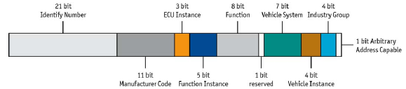

Address Claiming Procedure
In a common situation the controller application sends an Address Claim parameter group at start up and waits a defined amount of time. If it does not detect an address conflict it can start with its normal communication.
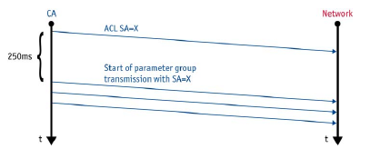
In a situation where another CA already uses the address an address conflict occurs. The CA with the higher priority of the device name will obtain the address. The other CA must send a “Cannot Claim Address” parameter group, with source address Null (254).
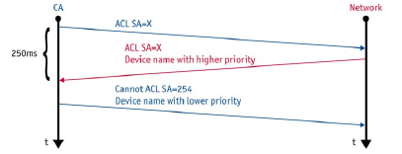
It depends on the address capability of a CA how to proceed, if an address cannot be obtained.

Request for Address Claim
A CA can detect other CAs in the network by requesting the ACL parameter group. It is allowed to use the Null- Address (254) as source address before a CA has performed the address claiming procedure. If the request is addressed to the Global address (255) all CAs in the network must respond with the ACL parameter group (including own CA if an address has been claimed already).

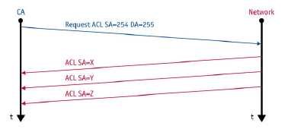
Address Capability
SAE J1939-81 defines the following types of capability to obtain an address:

Arbitrary address capable CA
The CA selects it source address by internal algorithm. It is able to select a new address on an address conflict. The Arbitrary Address Capable field in the device name indicates this capability.

Single address capable CA
A CA of this type can use only one address. On address conflicts it is not able to select another address. It can support the commanded address parameter group or proprietary mechanisms to change the address. The Arbitrary Address Capable field is not set for these CAs.

Transport protocol
Parameter groups that contain more than 8 data bytes are transmitted by means of a transport protocol.
For peer-to-peer and broadcast transmission, there are two different protocols. The transport protocols utilize two special parameter groups which are used for the connection management (TP.CM) and the transmission of the data (TP.DT).
For broadcast transmission, the BAM (Broadcast Announce Message) protocol is used. Here, after a BAM-PG, the transmitter sends all data PGs at a minimum interval of 50ms.
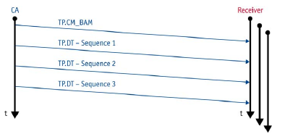
With the peer-to-peer transmission, the transmitter initiates the connection with a "request to send" message. The receiver then controls the transport protocol with "clear to send" and finally acknowledge it with "end of message acknowledge."
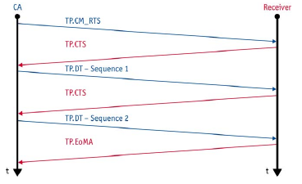

Diagnostic protocol
The diagnostic features of SAE J1939 supports following services:
- Reporting and identification of abnormal operation
- Memory access
- Monitored tests
An important parameter group is the Diagnostics Message 1 (DM1, PGN FECA16). If supported, it shall be sent cyclic by each CA to report its state. The parameter group contains the state for different lamps:
- Malfunction Indicator Lamp
- Red Stop Lamp
- Amber Warning Lamp
- Protect Lamp
An instrument cluster can use this information to report the state of the system to the driver. Additionally the parameter group contains a list of Diagnostic Trouble Codes (DTC). Together with the address of a sender the parameter of misbehaving components can be identified.
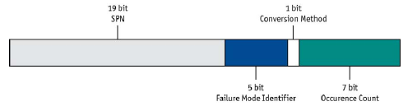
A DTC contains 4 bytes, which contain the SPN, the Failure Mode Identifier (FMI) and an Occurrence Count. If the DM1 contains more than one DTC a transport protocol must be used.

Reference
https://automotivetechis.wordpress.com/2012/06/07/memory-map-in-c/#more-93
http://unifieddiagnosticservices.blogspot.in/2011/12/automotive-diagnostics-services.html#!/2011/12/automotive-diagnostics-services.html
https://automotivetechis.files.wordpress.com/2012/06/presentation_debrecen_en_2008_03_27.pdf

